Database

Data/Information

Data can be facts related to any object in consideration. For example, your name, age, height, weight, etc. are some data related to us. A picture, image, file, pdf, etc. can also be considered data.

A database is a systematic collection of data. They support electronic storage and manipulation of data. Databases make data management easy.

A database is controlled by database management system (DBMS).

Database or Database System = Data + DBMS

Database Software / DBMS:

Database software is used to create, edit, and maintain database files and records, enabling easier file and record creation, data entry, data editing, updating, and reporting. The software also handles data storage, backup and reporting, multi-access control, and security. Strong database security is especially important today, as data theft becomes more frequent. Database software is sometimes also referred to as a “database management system” (DBMS).

A DBMS serves as an interface between the database and its end users or programs, allowing users to retrieve, update, and manage how the information is organized and optimized. A DBMS also facilitates oversight and control of databases, enabling a variety of administrative operations such as performance monitoring, tuning, and backup and recovery.

Some examples of popular database software or DBMSs include MySQL, Microsoft Access, Microsoft SQL Server, FileMaker Pro, Oracle Database, and dBASE.

Types of Databases:

1. Relational Database

Items in relational databases are organized as set of tables with rows and columns.

1. Object oriented database

Information in object-oriented database is represented in form of objects.

1. Distributed Database

A distributed database consists of two / more files located on different sites / computers or scattered over networks.

1. Data Warehouses

A central repository for data. It contains historical data. Data warehouses specially designed for fast query and analysis.

1. NoSQL/NonRelational Databases

NoSQL (NonRelational) Databases allows unstructured and semi structured data to be stored and manipulated.

1. Cloud Databases

A cloud database is a collection of data, either structured or unstructured, that resides on a private, public, or hybrid cloud computing platform. There are two types of cloud database models: traditional and database as a service (DBaaS).

With DBaaS, administrative tasks and maintenance are performed by a service provider.

1. Document / Json Database

Json databases store data in JSON/Document format rather than rows and columns. Data/Record in json database are called document.

Create Database:

**Create database <DatabaseName>**

When we create a database, two types of files get generated automatically (i.e., every database creation weather system/user define database, two files get automatically generated). These two files are:

1. <DatabaseName>.mdf

This file contains actual data.

1. <DatabaseName>.ldf

This file contains transaction log file. It is used to recover database.

**Steps to view these files:**

Right click Database > Properties > Files Tab > Path

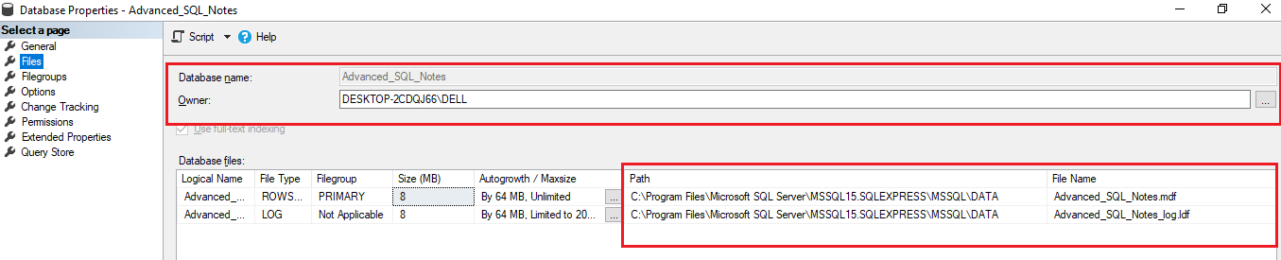

Drop Database:

**Drop database <DatabaseName>**

Dropping a database, deletes the .ldf and .mdf files behind the scenes.

We can’t drop a database if it is currently in use.

So, if other users are connected, we should put database in single user mode and then drop it.

Set Database at single user mode

Alter database <DatabaseName>

Set single_user with Rollback immediate

“With Rollback Immediate” command, SQL Server will rollback all incomplete transactions and connection to the database.

**Note:**

We can’t drop system databases (master, model, msdb, tempdb).

Renaming Database:

1. Alter Database <OldDatabaseName>

Modify Name=<newDBName>

1. execute sp_rename <oldDBName> <newDBName>

